Acquisition Plan

Template

Version X.x ● 05 December 2016

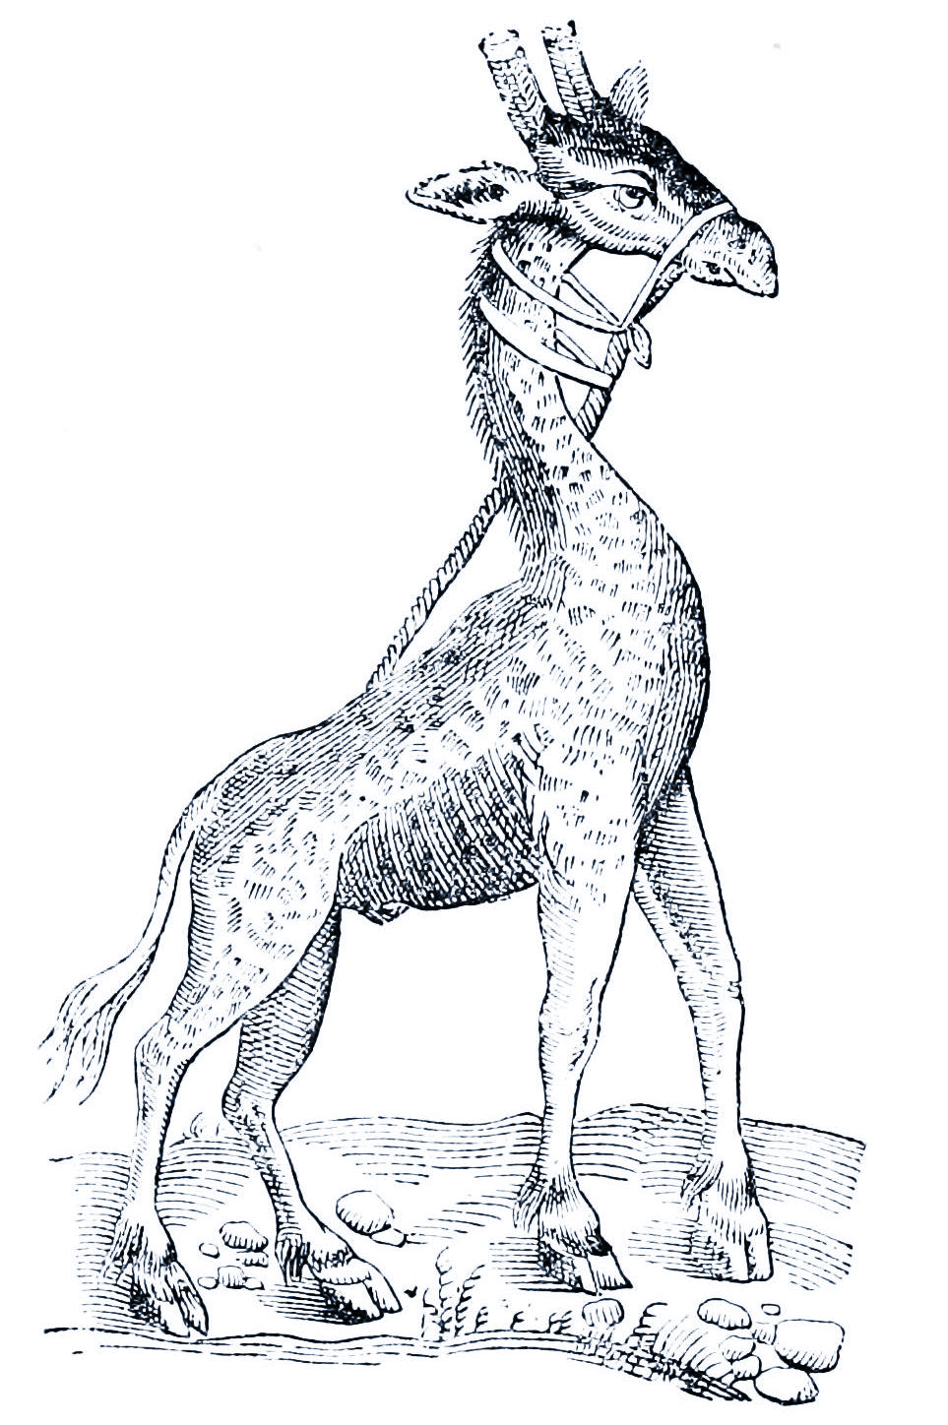

Company Name - Address - Telephone - Email - www.website.com

© [Year] [Company Name] or a [Company Name] affiliate company. All rights reserved.

[Company] [Address]

[Phone] [Fax] [Website]

**Trademarks**

[Product Name] are registered trademarks of [Company]. All other trademarks or registered trademarks are the property of their respective owners.

**Disclaimer**

The information provided in this document is provided "as is" without warranty of any kind. [Company Name] disclaims all warranties, either express or implied, including the warranties of merchantability and fitness for a particular purpose. In no event shall [Company Name] be liable for any damages whatsoever including direct, indirect, incidental, consequential, loss of business profits or special damages, even if [Company Name] or its suppliers have been advised of the possibility of such damages.

**Document Lifetime**

[Company Name] may occasionally update online documentation between releases of the related software. Consequently, if this document was not downloaded recently, it may not contain the most up-to-date information. Please refer to www.[website].com for the most current information.

From the Web site, you may also download and refresh this document if it has been updated, as indicated by a change in this date: [Date].

**Where to get help**

[Company Name] support, product, and licensing information can be obtained as follows.

**Product** **information** — For documentation, release notes, software updates, or for information about [Company Name] products, licensing, and service, go to the [Company Name] website at:

http://www.[website].com

**Technical** **support** — For technical support, go to http://www.[website].com and select Support. On the Support page, you will see several options, including one for making a service request. Note that to open a service request, you must have a valid support agreement.

**Your comments**

Your suggestions will help us continue to improve the accuracy, organization, and overall quality of the user publications. Please send your opinion of this document to:

Documentation@[Company Name].com

If you have issues, comments, or questions about specific information or procedures, please include the title and, if available, the part number, the revision, the page numbers, and any other details that will help us locate the subject that you are addressing.

Preface

**Style Conventions**

The following style conventions are used in this document:

**Bold**

Names of commands, options, programs, processes, services, and utilities

Names of interface elements (such windows, dialog boxes, buttons, fields, and menus)

Interface elements the user selects, clicks, presses, or types

*Italic*

Publication titles referenced in text

Emphasis (for example a new term)

Variables

Courier

System output, such as an error message or script

URLs, complete paths, filenames, prompts, and syntax

*Courier italic*

Variables on command line

User input variables

< > Angle brackets enclose parameter or variable values supplied by the user

[ ] Square brackets enclose optional values

| Vertical bar indicates alternate selections - the bar means “or”

{ } Braces indicate content that you must specify (that is, x or y or z)

Acquisition Plan

[Organization Name]

[Project Name]

Version: [Version Number] Revision Date [Date]

|  |  |  |
| --- | --- | --- |
| **Executive Sponsor** | | |
| [Name] | [Email] | [Telephone] |
| Signature | | Date |

|  |  |  |
| --- | --- | --- |
| **Technology Sponsor** | | |
| [Name] | [Email] | [Telephone] |
| Signature | | Date |

|  |  |  |
| --- | --- | --- |
| **Contract Manager** | | |
| [Name] | [Email] | [Telephone] |
| Signature | | Date |

|  |  |  |
| --- | --- | --- |
| **Project Manager** | | |
| [Name] | [Email] | [Telephone] |
| Signature | | Date |

|  |  |  |
| --- | --- | --- |
| **Legal** | | |
| [Name] | [Email] | [Telephone] |
| Signature | | Date |

|  |  |  |
| --- | --- | --- |
| **Security Officer** | | |
| [Name] | [Email] | [Telephone] |
| Signature | | Date |

Table of Contents

1 Acquisition Overview 8

1.1 Objectives 8

1.2 Background 8

1.3 Scope 8

1.4 Acquisition Plan Thresholds 9

1.5 Assumptions 9

1.6 Constraints 9

2 Acquisition Approach 10

2.1 Acquisition Strategy 10

2.1.1 Approach to Sourcing 10

2.1.2 Acquisition Method 10

2.1.3 Regulations 10

2.1.4 Funding 10

2.1.5 Lead Time 10

2.1.6 Considerations 11

2.1.7 Sources 11

2.2 Evaluation and Award 11

2.3 Procurements Activities Key Dates 12

3 Hardware Specifications 13

3.1 Hardware Compatibility 13

3.2 Processing Equipment 13

3.3 Communications 13

3.4 Special Equipment 13

3.5 Support Services 13

3.6 Site Preparation 13

4 Software Specifications 14

4.1 Required Capabilities 14

4.2 Capacity 14

4.3 Documentation 14

4.4 Maintenance Features 15

4.5 Sources 15

4.6 Impact 15

5 Contact Management 16

5.1 Vendor Orientation 16

5.2 Change Management 16

5.3 Deliverables Management 16

5.4 Invoice Management 16

5.5 Dispute Resolution 16

5.6 Contract Closeout 16

5.7 Tools 16

6 Appendix A 17

6.1 Glossary of Terms 17

6.2 Acronyms and Abbreviations 17

Document History

Paper copies are valid only on the day they are printed. Contact the author if you are in any doubt about the accuracy of this document.

Revision History

|  |  |  |  |
| --- | --- | --- | --- |
| Revision Number | Revision Date | Summary of Changes | Author |
|  |  |  |  |
|  |  |  |  |
|  |  |  |  |

Reference Documents

Please see the following documents for more information:

|  |  |  |
| --- | --- | --- |
| Document Name | Version | Author |
|  |  |  |
|  |  |  |
|  |  |  |

Distribution List

This document has been distributed to:

|  |  |  |  |
| --- | --- | --- | --- |
| Name | Position | Company | Action |
|  | IT Manager | Supplier | Reviewer |
|  | Business Unit | Customer | Review |
|  | Technical Writer | Supplier | Author |
|  | Product Manager | Supplier | Reviewer |

# Acquisition Overview

The Acquisition Plan addresses acquisition activities such as acquisition of hardware, software, and infrastructure services to [Company] as well as [Suppliers] who will provide and maintain these tools, and provide support in the development, testing, and maintenance of the system.

## Objectives

Describe the purpose of the acquisition plan and how the procured goods and/or services will be used to address the business/technical problem. Describe how the acquisition plan will analyze the technical options and the lifecycle plans for development, production, training, and support related items.

The purpose of this acquisition plan is to:

## Background

Provide additional information that supports and defines the overall procurement process. Identify the estimated total contract amount, duration of need, and projected life of the project. Describe the system for which the acquisition plan will be implemented. Provide any historical information where relevant, e.g. performance or security related issues.

|  |  |
| --- | --- |
| Estimated Contract Amount | Project Duration [MM/YY to MM/YY] |
|  |  |

## Scope

Define the procurement limits in terms of the goods and/or services that will be delivered. The scope establishes the boundaries of the procurement process and should describe goods and/or services that are outside of the procurement scope.

|  |  |
| --- | --- |
| Project Includes | |
|  |  |
|  |  |
|  |  |

|  |  |
| --- | --- |
| Project Excludes | |
|  |  |
|  |  |

## Acquisition Plan Thresholds

Outline the thresholds that apply for each department.

|  |  |  |  |
| --- | --- | --- | --- |
| Threshold | Reviewer | Approver | Date |
| <$1m |  |  |  |
| <$5m |  |  |  |
| <$10m |  |  |  |
|  |  |  |  |
|  |  |  |  |

## Assumptions

Include assumptions related to business, technology, resources, scope, expectations, or schedules.

|  |  |  |
| --- | --- | --- |
| Ref. # | Assumption | Impact |
|  |  |  |
|  |  |  |
|  |  |  |
|  |  |  |

Table 1 — Assumptions

## Constraints

Describe any constraints that impact the procurement process. Include constraints being imposed in areas such as schedule, budget, resources, products to be reused, technology to be deployed, products to be acquired, and interfaces to other products.

|  |  |  |
| --- | --- | --- |
| Ref. # | Constraint | Impact |
|  |  |  |
|  |  |  |
|  |  |  |
|  |  |  |

Table 2 — Constraints

# Acquisition Approach

This section describes the factors, constraints, and selection process used to acquire the respective items. It also outlines the support and acquisition activities that require assistance from other organizations and the associated timeframes.

## Acquisition Strategy

Describe the strategy for how the procurement effort will be conducted, including the sourcing approach, procurement method, competition, and procurement steps.

### Approach to Sourcing

Describe the sourcing approach and justify why the planned sourcing (e.g., full outsourcing, partial outsourcing, multi-sourcing) is the best option and why existing staff cannot provide the desired goods and/or services.

|  |  |
| --- | --- |
| Sourcing Approach | Justification |
|  |  |

### Acquisition Method

Describe the planned procurement method (e.g., leveraged procurement, competitive bid, and competitive proposals). Identify the various options for acquiring new products, for example:

* Lease vs. Purchase – Evaluate the benefits of leasing the item versus purchasing it. Factors to consider include costs during the projected project life, obsolescence, future expansion, etc.
* Request For Proposal - An RFP should be considered as opportunity to evaluate prospective suppliers.

### Regulations

Identify any government regulations that support the acquisition. Identify any limitations that these regulations may impose upon the new system.

### Funding

Identify the source(s) of funds for the acquisition, including information related to its budget, accounting codes, etc.

### Lead Time

Identify the lead times for each phase of the process. Highlight when the product (i.e. system) must be available and operational.

### Considerations

Describe any considerations related to the following areas that need to be highlighted:

* Computer-Related
* Contract administration
* Environmental, Health, and Safety
* Hazardous Waste
* Logistics considerations
* Nuclear Materials
* Security Considerations

### Sources

Identify potential suppliers who can provide hardware, software, network etc that meet your requirements.

## Evaluation and Award

Outline the approach to qualifying suppliers, e.g. formal evaluation process. Describe the evaluation approach, including evaluation factors and overall use for vendor selection.

Identify and describe any tools used for vendor selection, including any conditions imposed by the tools such as how the evaluation factors are defined and used.

## Procurements Activities Key Dates

Identify key dates for procurement activities that require specific actions to occur in order to move the procurement forward. These dates are a subset of the milestones and deliverables as reflected for project delivery.

List both pre-solicitation and solicitation activities.

|  |  |
| --- | --- |
| Pre-solicitation Activities / Deliverables | Justification |
|  |  |
|  |  |
|  |  |
|  |  |

|  |  |
| --- | --- |
| Solicitation Activities / Deliverables | Justification |
|  |  |
|  |  |
|  |  |
|  |  |

# Hardware Specifications

Describe the hardware acquisition activities for the task, including the responsible parties and the start and completion dates for each activity. In addition, identify any activities that must be met before additional acquisition activities can proceed. Describe the equipment, communications, support services, and site preparation that will be required.

## Hardware Compatibility

Identify any hardware compatibility issues that will impact the acquisition process. Specify the different types of hardware, vendors, operating system, etc that are required.

## Processing Equipment

Identify the equipment required to run the system, including type, size, speed etc.

Include details of the setup, operations and maintenance documentation.

## Communications

Describe the communications equipment, services, and facilities required by the system.

Where appropriate, include details of the existing and/or proposed networks.

## Special Equipment

Identify any special equipment that is required. Specify the costs, sources, and costs, as staff responsible for overseeing the equipment.

## Support Services

Identify the support services required to install and maintain the hardware, including the repair, maintenance and staff training.

## Site Preparation

Identify the sites that will require preparation in order to receive the hardware and/or software.

Describe the nature of the required modifications, such as expected downtimes, interruptions and potential issues.

# Software Specifications

In this chapter, describe the required capabilities, features and capacity of the software. Identify hardware compatibility issues, system documentation, training, and system maintenance.

## Required Capabilities

Describe the required capabilities for the system, i.e. the main product features. Identify these features in advance before evaluating any software products.

When evaluating the system, use a scoring matrix to evaluate the different requirements e.g. useful, desirable and mandatory requirements.

|  |  |  |  |  |
| --- | --- | --- | --- | --- |
| Feature | Mandatory | Score | Weight | Total |
| [ ] | Yes | 100 | 2.0 | 200 |
| [ ] | No | 50 | .5 | 25 |
| [ ] | Etc | 50 | .5 | 25 |
|  | Total |  |  | 250 |

Table 3 — Required Capabilities Matrix

## Capacity

Outline the expected data volumes that the system will handle per year.

|  |  |
| --- | --- |
| Data Volume | Year |
|  |  |
|  |  |
|  |  |
|  |  |

Table 4 — Capacity

## Documentation

Identify the documentation that will be required for the system. Estimate the cost, quality and availability of the documents to be provided, for example;

* Installation Guides
* Operations Guides
* System Administration Guides

If relevant, state the required document format, e.g. context sensitive Online Help.

## Maintenance Features

Describe how you will handle software errors and discrepancies in the system functionality, e.g. Service Level Agreements with the supplier. Highlight when software updates/upgrades will be released.

## Sources

Identify potential software vendors who provide software solutions that suit your requirements.

Identify the manufacturer or distributor, lead times, financial incentives (e.g. licensing agreements), warranties, and estimated costs.

## Impact

Describe the impact of acquisition on existing system operations and architecture.

# Contact Management

## Vendor Orientation

Describe the approach for vendor orientation.

## Change Management

Describe how contract changes will be managed.

## Deliverables Management

Describe how all planned and actual contractor deliverables and services will be tracked and managed, including due dates, actual submission dates, approval/rejection, and other data as needed.

## Invoice Management

Describe how invoices will be managed.

## Dispute Resolution

Describe how contractual disputes will be handled, including escalation of dispute issues to appropriate agency staff.

## Contract Closeout

Describe the approach for contract closeout.

## Tools

Describe any tools used to manage the contract, contractual requirements, and deliverables.

# Appendix A

Attach any addition information that supplements this plan.

## Glossary of Terms

Identify all terms that establish meaning within the context of the plan.

|  |  |
| --- | --- |
| Term | Meaning |
|  |  |
|  |  |
|  |  |
|  |  |
|  |  |

Table 5 — Glossary of Terms

## Acronyms and Abbreviations

Identify all acronyms and abbreviations used in this document.

|  |  |
| --- | --- |
| Acronym | Meaning |
|  |  |
|  |  |
|  |  |
|  |  |
|  |  |

Table 6 — Acronyms and Abbreviations